- SETTINGS
  - ROLE LIST
    - Role List View:
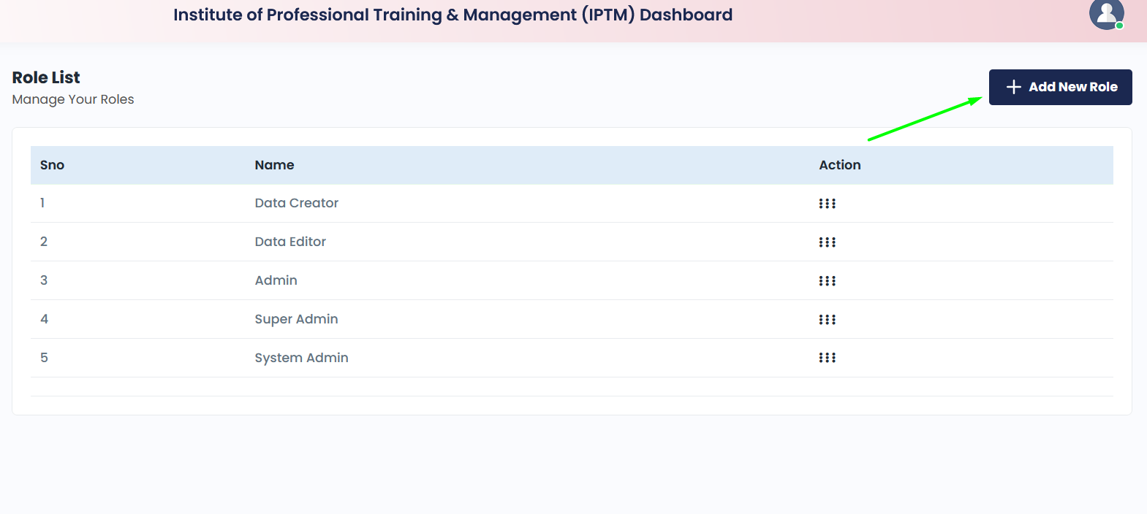
    - New Role Create:

    - Role Edit:
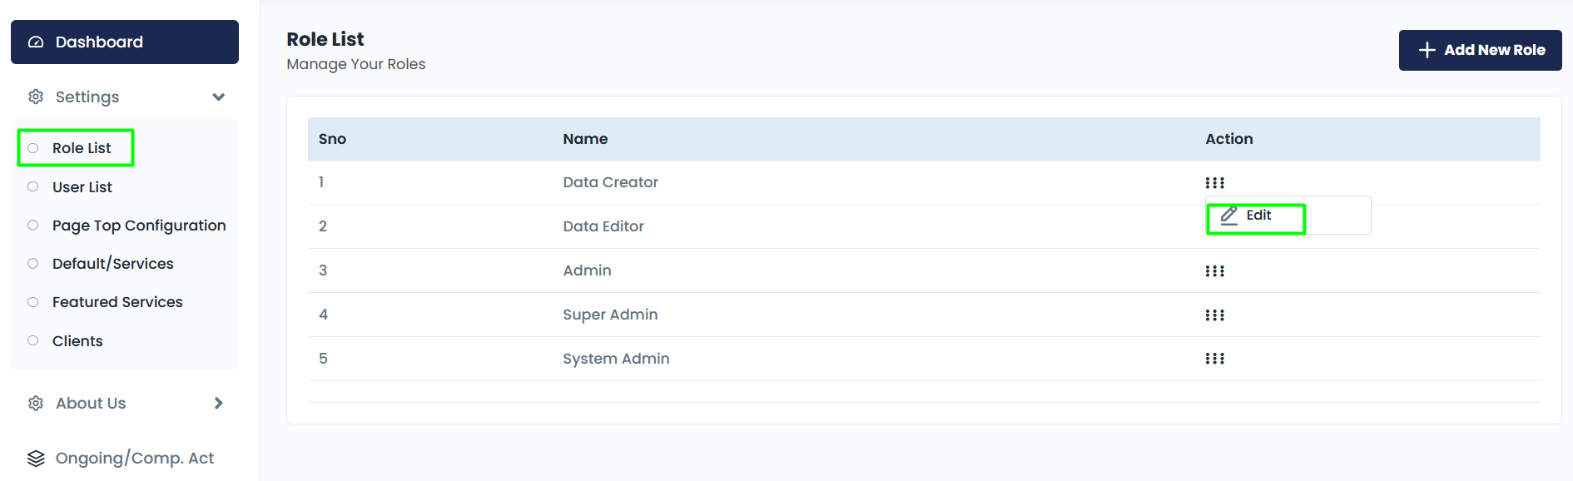
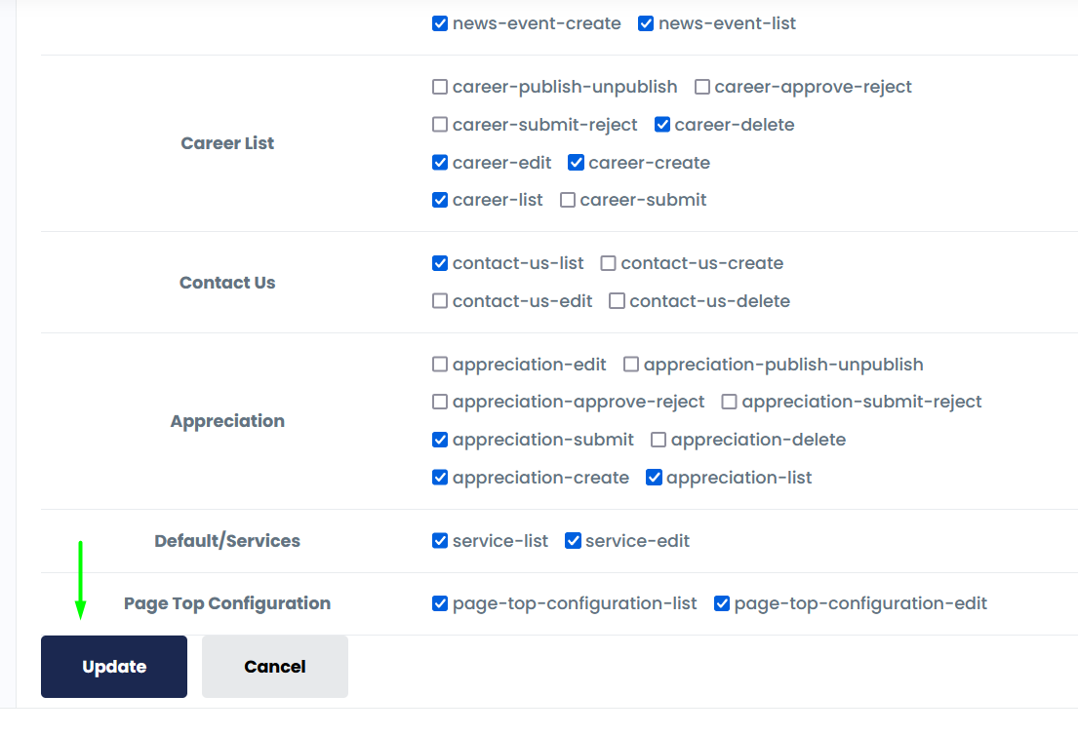

  - USER LIST
    - User List View
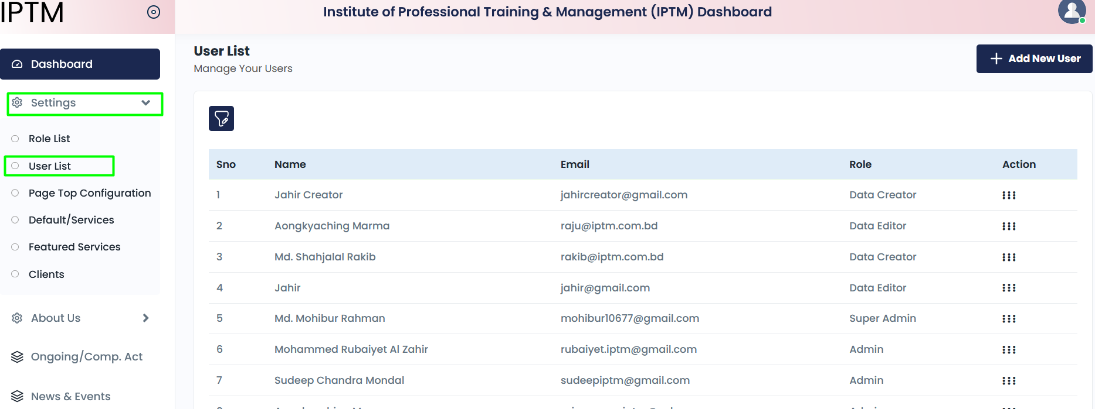

    - New User Create
      - Click on “Add New User” button.
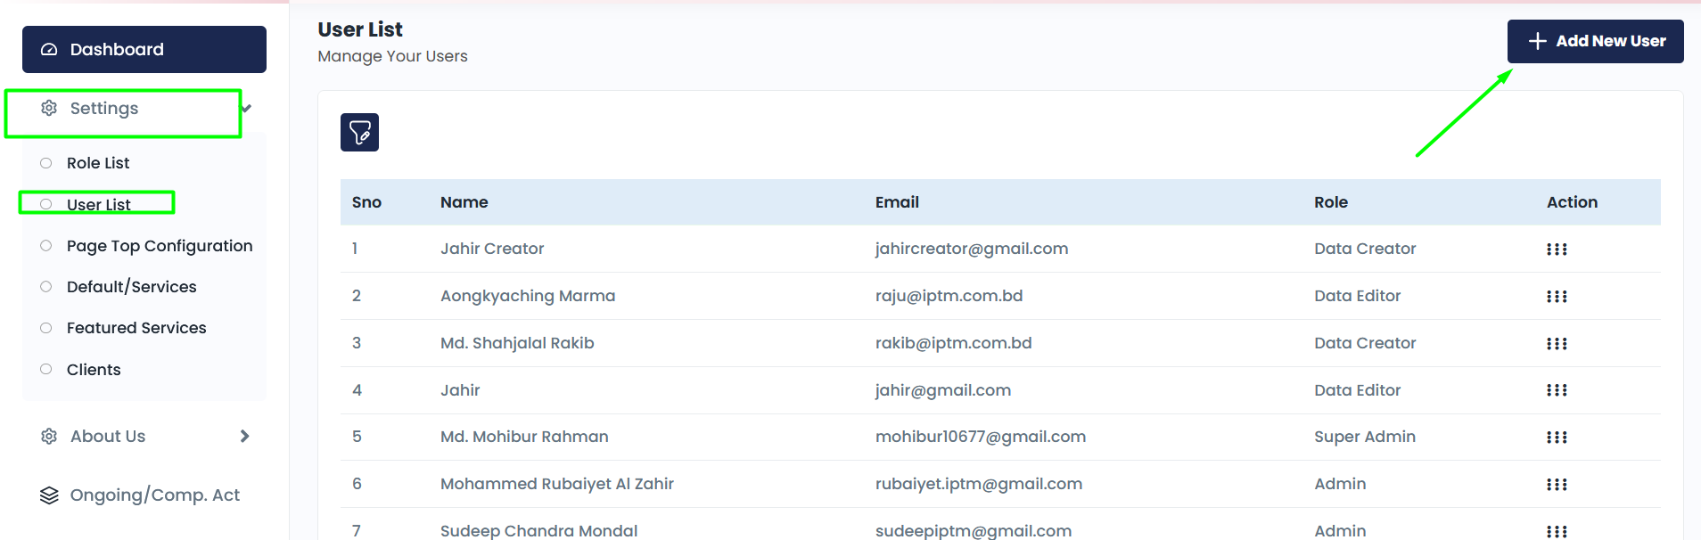
      - Fill up all field and and click on “Submit” button
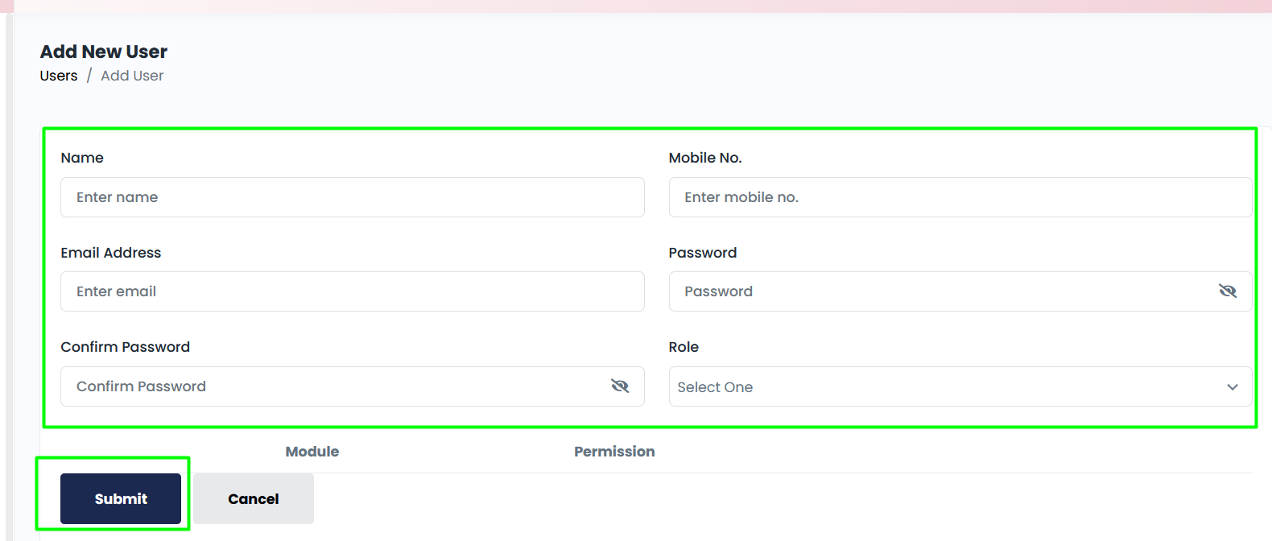

    - User Edit
      - Click edit button
      - Modify information and change user roll wise permission. In this section, define different permission for same role user. Although roll it but permission can be change by user wise.
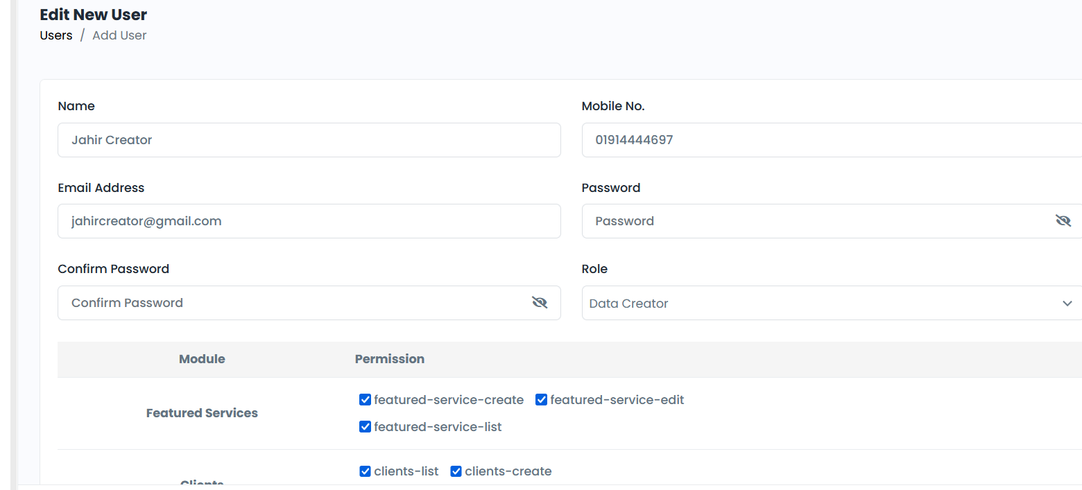

    - User Delete

  - PAGE TOP CONFIGURATION
  - DEFAULT/SERVICES
  - FEATURED SERVICES
  - CLIENTS
- ABOUT US
  - CORE INFO
  - OTHER INFO
  - TEAM MEMBERS
- ONGOING/COMP. ACT
- NEWS & EVENTS
- OUR APPRECIATIONS
- CAREER
- CONTACT US

